# Table access full scan

## Task 1: Full Scans and the High-water Mark and Block reading

Step 1:

After create table:

1664

1536

recursive calls 4

db block gets 0

consistent gets 1606

physical reads 0

redo size 0

bytes sent via SQL*Net to client 1127

bytes received via SQL*Net from client 1024

SQL*Net roundtrips to/from client 3

sorts (memory) 0

sorts (disk) 0

Step 4: Delete All Rows from table

# DELETE FROM t2;

1664

0

recursive calls 0

db block gets 0

consistent gets 1541

physical reads 0

redo size 0

bytes sent via SQL*Net to client 1126

bytes received via SQL*Net from client 1024

SQL*Net roundtrips to/from client 3

sorts (memory) 0

sorts (disk) 0

Step 6: Insert 1 row

# INSERT INTO t2

( ID, T_PAD )

VALUES

( 1,'1' );

COMMIT;

1664

1

recursive calls 0

db block gets 0

consistent gets 1541

physical reads 0

redo size 0

bytes sent via SQL*Net to client 1127

bytes received via SQL*Net from client 1024

SQL*Net roundtrips to/from client 3

sorts (memory) 0

sorts (disk) 0

Step 8: Truncate Table

# TRUNCATE TABLE t2;

8

0

recursive calls 1

db block gets 0

consistent gets 5

physical reads 0

redo size 0

bytes sent via SQL*Net to client 1126

bytes received via SQL*Net from client 1024

SQL*Net roundtrips to/from client 3

sorts (memory) 0

sorts (disk) 0

**Task Results:**

Expected:

Summary table with all result and text description of analyses this results.

|  |  |  |  |  |  |
| --- | --- | --- | --- | --- | --- |
| № | Count of Blocks | Count of Used Blocks | Count of Rows | Consistent gets | Description |
| create | 1664 | 1536 | 999999 | 1606 | Select returned rows |
| delete | 1664 | 0 | 0 | 1541 | Select return |
| isert | 1664 | 1 | 1 | 1541 |  |
| truncate | 8 | 0 | 0 | 5 |  |

# Index Scan types

## Task 2: Index Clustering factor parameter

**Task Results:**

Expected:

* Screenshot of the step 5;

IDX_NAME,CLUSTERING_FACTOR,BLOCKS,NUM_ROWS

T1.T1_IDX1,99999,1550,99999 (distincyt 100 rows)

T2.T2_IDX1,1538,1570,99999 (1000 disticnt rows)

* Description of the parameter clustering factor;

CLUSTERING_FACTOR – shows if index shows just strait to block.

If CLF = block size, it’s very good and table is orderd.

* Explanation: why for indexes t1_idx1 and t2_idx1 we have different values

Because T1.T1_IDX1,99999,1550,99999 **(distincyt 100 rows)**

T2.T2_IDX1,1538,1570,99999 (**1000 disticnt rows)**

* Which Index has best selective performance in execution Select clause filtered by IN ( , list of values, );

Access t1:full table;

Access t2:by index.

## Task 3: Index Unique Scan

Step 1:

# CREATE UNIQUE INDEX udx_t1 ON t1( t_pad );

**Step 2**

# SELECT t1.* FROM t1 where t1.t_pad = '1';

**Task Results:**

Expected:

* Screenshot of the step 2;

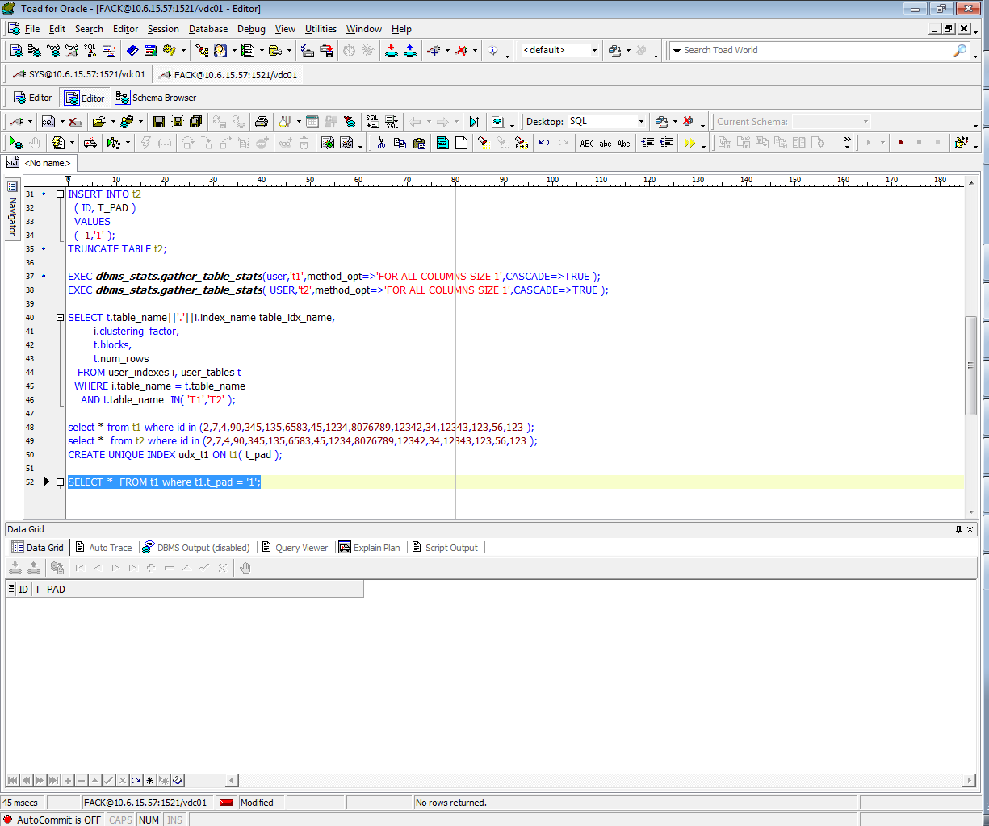

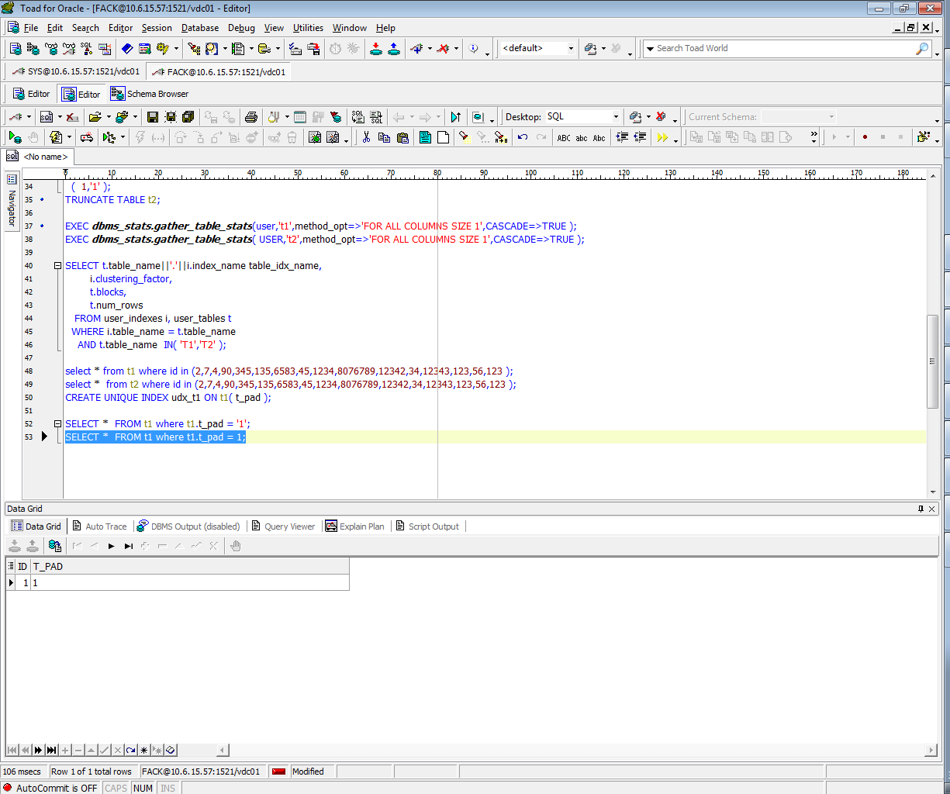

* Description of process: How oracle read block on step 2;

I don’t why, but according the paln, it would read by index full scan. If we would delete ‘’ it would read by access full table.

## Task 4: Index Range Scan

**Step 1:**

# SELECT t2.* FROM t2 where t2.id = '1';

**Task Results:**

Expected:

* Screenshot of the step 1;

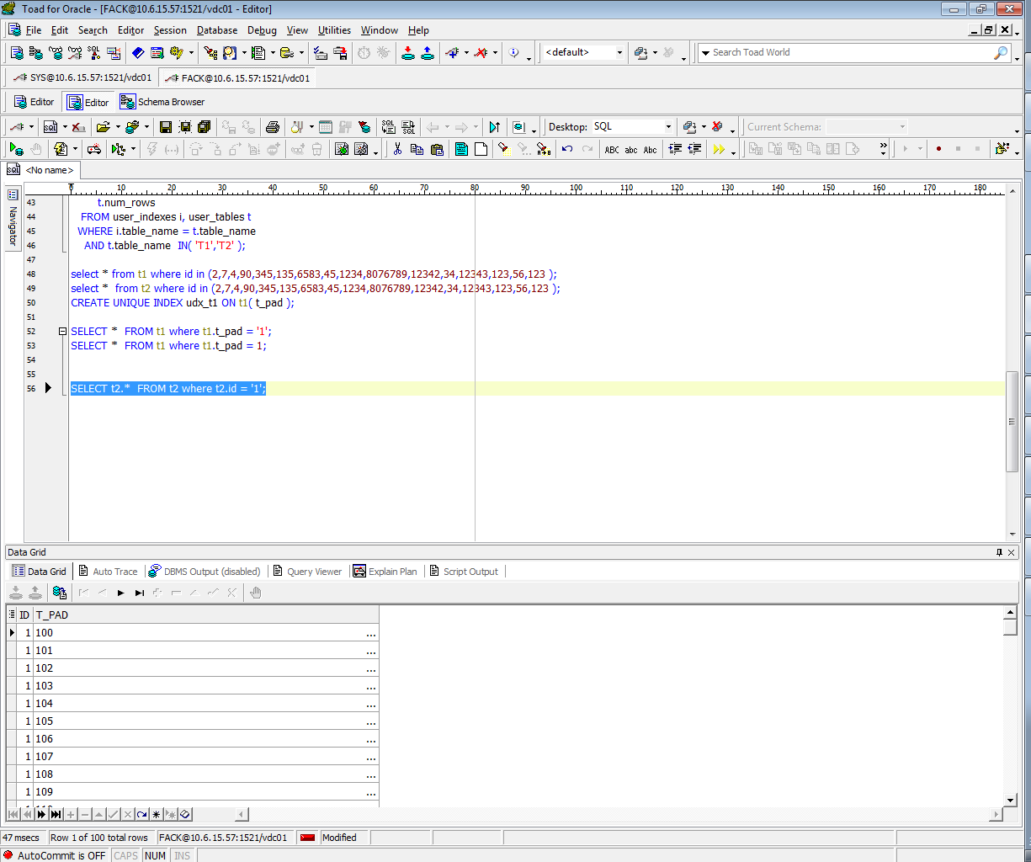

* Description of process: How oracle read block on step 1;

It would read **Index Unique Scan**

## Task 5: Index Skip Scan

Step 1:

# CREATE TABLE employees AS

SELECT *

FROM scott.emp;

Step 2:

# CREATE INDEX idx_emp01 ON employees

( empno, ename, job );

**Step 3:**  Get trace and statistic of explain plan

# SELECT /*+INDEX_SS(emp idx_emp01)*/ emp.* FROM employees emp where ename = 'SCOTT';

recursive calls 0

db block gets 0

consistent gets 2

physical reads 0

redo size 0

bytes sent via SQL*Net to client 1926

bytes received via SQL*Net from client 1138

SQL*Net roundtrips to/from client 3

sorts (memory) 0

sorts (disk) 0

# SELECT /*+FULL*/ emp.* FROM employees emp WHERE ename = 'SCOTT';

recursive calls 0

db block gets 0

consistent gets 3

physical reads 0

redo size 0

bytes sent via SQL*Net to client 1922

bytes received via SQL*Net from client 1094

SQL*Net roundtrips to/from client 3

sorts (memory) 0

sorts (disk) 0

**Task Results:**

Expected:

* 2 Screenshots of the step 3;
* Description of process: How oracle analyses index that was created on step 2;
* Summary table with all result and text description of analyses this results.

|  |  |  |  |  |  |
| --- | --- | --- | --- | --- | --- |
| № | Count of Blocks | Count of Used Blocks | Count of Rows | Consistent gets | Description |
| 1 | 8 | 1 | 14 | 2 |  |
|  | 8 | 1 | 14 | 3 |  |
|  |  |  |  |  |  |
|  |  |  |  |  |  |